ADDENDUM 2

DATE: July 29, 2019
PROJECT: MSB Air Distribution Floors 1-4
RFP NO: 744-R1920
OWNER: The University of Texas Health Science Center at Houston
TO: Prospective Proposers

This Addendum forms part of and modifies Proposal Documents dated, June 28, 2019, with amendments and additions noted below.

1. Submittal Deadline REVISION:

The Submittal Deadline is being extended as noted below.

UTHealth will accept proposals submitted in response to this RFP until 2:00 p.m., CST on Friday, August 2, 2019 (the “Submittal Deadline”).

HUB Submittal Deadline is 2:00 p.m., CST on Monday, August 5, 2019

2. Clarifications, Questions and Answers:

- Clarification: Please confirm that ALL corridor/hallway flooring is intended to be part of the Alternate #2 pricing. Notes on the Finish Material Schedule (A-142) only specifically note VCT as being part of the alternate, but there is also some Carpet Tile being installed in the corridors. Please clarify.
Answer: Carpet in the corridors will be part of the base.

- Clarification: Please provide a basis of design for the Alternate #9, Luxury Vinyl Tile, for the Grand Stair.
Answer: (PWP provide a recommendation)

- Clarification: Please confirm that the Owner contracted abatement company will remove all the terminal units and ductwork.
Answer: Correct.

- Clarification: Please confirm that pricing for the Alternate #9, Luxury Vinyl Tile, will be based off the manufactures standard color selection. If custom/premium colors are expected to be required, please advise.
Answer: Correct.

- Clarification: Please provide basis of design for the stainless-steel corner guards required for Alternate #10 and confirm that they are to be 4’ long.
Answer: See level 1 for existing corner guard basis of design.

- Question: The finish plans currently have a several rooms with the “Not in Project Scope” shading. Although they are shaded as not part of the project, they have Finish Tags, for new flooring, paint, etc. Are contractors to include ALL rooms noted with new finish tags or assume that no work is to be completed in those rooms. Reference room numbers 2.010, 2.022, 2.025, 2.025A, 2.0T1, 2.0T2, and 2.0J1.
Answer: PWP will issue revised drawing. See E&C Addendum 01.

- Clarification: Please confirm that Finish Type Mark “F3” will required Base Type “RBC.” The Room Finish Type Schedule currently does not have a flooring base indicated for this Finish Type Mark.
Answer: PWP will issue revised drawing. – not RBS, revised to be coved base. See E&C Addendum 01.

- Clarification: Please provide locations for new Rubber base, straight “RBS.” The Finish Material Schedule notes this rubber base, but this base is not being called for at any locations.
Answer: PWP will issue revised drawing. – not RBS, revised to be coved base. See E&C Addendum 01.

- Question: Corner guards required to be reinstalled in base bid are not being noted on the plans. Are contractors to assume that every corner located in the corridors/hallways will have an existing corner guard?
Answer: Yes.

- Clarification: Sheet A-142 (Finish Plan Level 1) has a corridor shaded as “Not in Project Scope,” located Plan North, in between column lines 7 and 11. Please confirm that contractors are not to include any new finishes or lighting in this area. Electrical Lighting and Reflected ceiling plans appear to show new ceilings and lights in this corridor but there is no demo being called for in this space.
Answer: Ceiling grid will be reworked to modify lighting layout. Existing lights will be reused. Additional lights will be returned to owner for stock.

- Clarification: Room Finish Types “F8” and “F9” only call for the replacement of acoustical ceiling tiles (ACT1) and do not note new ceiling grid (ACT2) on the Room Finish Type Schedule. Please confirm that all Room Finish Types requiring new Acoustical Ceiling Tiles will also require a new ceiling grid (ACT2).
Answer: Confirmed. New ceiling grid required at ACT2.

- Clarification: Please provide signage vendor contact information.
Answer: Drew DeFoor
Signarama
12919 Southwest Freeway Suite 150
Houston, Texas 77477

- Question: New flooring base will be required in the corridors/hallways if Alternate #1, remove existing vinyl wall covering, is accepted. New flooring base in the same areas will be required if Alternate #2, install new flooring in hallways, is accepted. Are contractors to include new corridor flooring base in Alternate #1 or Alternate #2 pricing.
Answer: Include in Alternate #2, not in #1

- Clarification: Please confirm that TAB and Cx scope will be by Owner.
Answer: Confirmed.

- Question: General Note A in the Electrical Lighting Plans state that new lights are 3” deep and that “some sprinkler pipe routed tight to the ceiling may need to be relocated.” Since the extent of this scope of work on all 4 levels of work cannot be quantified at the time of the bid, will this work by priced post bid or will the Owner give an allowance for all contractors to carry.
Answer: Move light fixture as required to not be in conflict with existing overhead systems, will be in Owner’s contingency if required (previous 3 floors not an issue).

- Clarification: Please provide electrical drawings showing existing panel locations. This will be required to calculate new circuit lengths.
Answer: Electrical drawings for lighting show panel locations in the chase. For example, Drawing E2.41 has note #7 showing panel 4LB and 4LD. All circuits that were free at the time of walk-thru were also noted on this note. This is similar of all electrical floor plans.

- Clarification: Please confirm that all flooring demo will be by the Owner, through direct contract with an abatement company.
Answer: Asbestos containing material will be removed by owner. Contractor shall list cost to demo non-ACM flooring per unit of measure.

- Clarification: Please provide plumbing drawings showing all Toilet Toom work being called for in Enlarged Plan 4/A-143. The plan calls for replacement of urinals, removal of toilets and exposed pipe insulation at sinks but does not provide any specific requirements or model numbers needed for pricing.
Answer: Please see revised drawings for E&C Addendum 01.

- Clarification: Enlarged Plan 4/A-143 calls for the removal of toilets and stalls to accommodate new ADA stalls but there is not a new layout required for pricing. Please provide additional plans showing new layouts required and dimensions.
Answer: See Architectural Plans – 2/A-143.

- Clarification: Please provide specifications and requirements for new stalls being called for on, Enlarged Plan, 4/A-143.
Answer: Match existing ADA restroom stalls from Level 1.

- Question: Enlarged Plan 4/A-143 calls for the removal of certain paper towel dispensers, soap dispensers, feminine product dispensers and hand dryers. Only a “new model” hand dryer is called for. Are contractors to assume that all other items are not being replaced?
Answer: Toilet Accessories will be OFCI other than hand dryer. (PWP to provide model number ADA compliant) (See attached cutsheet)

- Clarification: Please provide call outs and model numbers for all new toilet accessories.
Answer: PWP to provide model information for Toilet Accessories from Level 1. (See attached)

- Enlarged Plan 4/A-143 calls for the replacement of the automatic push buttons.
  - Please confirm that this is typical for all automatic push buttons at public Toilet Rooms in Levels 2-4.
Answer: Include as shown on plans.
  - Please confirm that the automatic door operator will not need to be replaced. If so, provide model #s.
Answer: Repair or Replace Existing Door operators as required – *Assume replacement of 2, repair of 4 (Alternate #50 on Electrical Drawings)
  - Please model numbers for replacement automatic push buttons required.
Answer: Match existing adjacent restroom push button if replacement is required.

- Clarification: Enlarged Plan 4/A-143 states that it is typical for levels 2-4. Please confirm that none of the work called for on that Enlarged Plan is to be done to the Toilet Rooms on level 1.
Answer: Toilet Rooms on Level 1 not in scope

- Clarification: Drawing E2.11 to E2.16 Note #7 as well as the other floors are asking for new circuits for the controls. I did not see where the electrical panels are located on electrical or architectural drawings. Please clarify as to locations of electrical panels.
Answer: Look for note #7 in the chases just to the east and west behind the elevator, then follow north-south for each chase. They are shown on E2.11, 2.12, 2.14 & 2.15 in that location. In 2.13 & 2.16 that area is a little different. Look for the note and panel call-out on 2.13 right behind the blue elevators and on 2.16 in the chase labeled 1.1M4.

- Clarification: Drawing E1.11 shows (8) fixtures to be removed in the upper left-hand corner. But on the RENO Drawing E2.11 shows no new fixtures going back. Please clarify?
Answer: Please refer to the E&C Addendum 01 drawings.

- Question: Drawing E2.11 has (2) symbols that are on the drawing but not on the legend an S in a square box and a SD in a square box. Please clarify? Also, there is an AV in a circle which is similar to the Fire Alarm AV symbol in a square box with a horn. Is this AV symbol in the circle a Ceiling mounted Audio-Visual symbol? The note with the symbol has it as a fire alarm device. Please Clarify?
Answer: The S and SD in square boxes are faceplates to LEDs noting status of smoke dampers above the ceiling. They are to stay in the location and new ceiling be placed around them. The AV circle is a strobe in the ceiling, while the AV square is a strobe on the wall. Those are part of the fire alarm system. The strobes should be remaining in place.

- Clarification: Please confirm that Hallway 2.2H3 is to be Room Finish Type “F3” and not “F2” as called for on Sheet A-143.
Answer: Confirmed, should be F3. PWP to provide revised drawing.

- Clarification: The following highlighted area on (E1.11) Level 01, Area A, is calling for the demolition of several lights but the new electrical reno plans for this same area (E2.11) do not show any new lights. Please confirm that this highlighted area is out of the project scope and existing lighting and ceiling is to remain, as shown in the Architectural plans.
Answer: Please refer to the addendum drawings.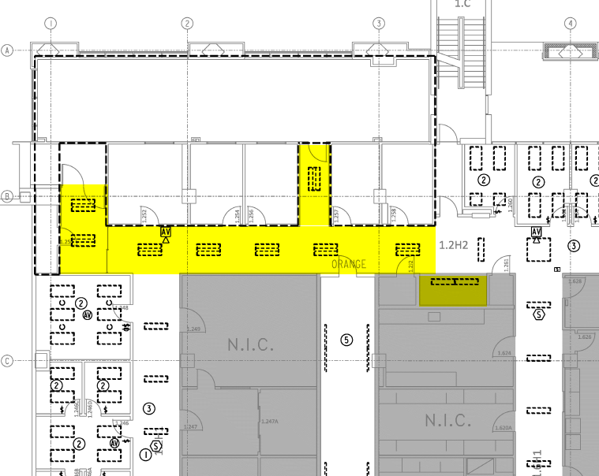

- Question: Is new Acoustical Ceiling Tile and Grid required at the level 1 restrooms?
Answer: See E&C Addendum 01 revised drawings.

- Question: Room # 2.103 has a Room Finish Mark “F2,” which calls for new ACT1&2. The Reflected Ceiling plans for this room do not show any new ceilings. Please confirm new ceilings are not required for Room #2.103.
Answer: No architectural scope, See E&C Addendum 01.

- Clarification: Hallway # 2.1H4 has a Room Finish Mark “F3,” which calls for new ACT1&2. The new Reflected Ceiling plans for this Hallway mark it as “Not in project Scope”. Please confirm new ceilings are not required for Hallway # 2.1H4.
Answer: See E&C Addendum 01.

- Question: Are door frames that are in the offices and serve as access between the offices to be included in the base price?
Answer: Yes.

- Clarification: The RFP document for this project states, under section 2.10 Prevailing Minimum Wage Rate Determination, that contractors are to “use the most recent Prevailing Wage Determination for Houston/Galveston Area Rates.” Please confirm that contractors are to use the Harris County Building Construction Prevailing Wage Rates for Quarter 3 of 2019, provided via the link located in the RFP, and we are not to use the old 2015 UT System Prevailing Wage rates located in “Appendix 6 – Special Conditions.” Images below are of the two sets of prevailing wages located in the project documents.
Answer: Please see attachment with the rates for Houston Galveston 2015. It has been confirmed these are the prevailing wages to be used.
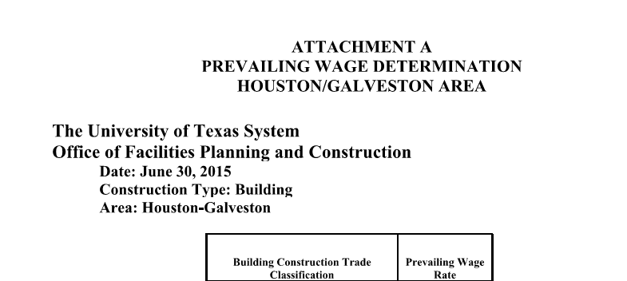

- Question: Are the exit signs new or existing? If they are new
Answer:
  - What type is needed? Please add models to schedule.
Answer: Existing to remain.
  - How will they be circuited, from closest power source or new circuit for all exit signs?
Answer: Existing to remain.

- Clairification: Exit signs are missing from the 2nd floor electrical drawings. If contractors are required to provide new please update.
Answer: Existing to remain.

- Clarification: Drawing E1.12 Lights to be demoed are missing from upper hallway and bathroom. Drawing E2.12 shows new lighting going in.
Answer: See E&C Addendum 01.

- Clarification: Drawing E1.13, E1.16, E1.44 and E1.46 Lights to be demoed are missing from bathroom. Drawing E2.13, E2.16, E2.44 and E2.46 shows new lighting going in.
Answer: See E&C Addendum 01.

- Clarification: Drawing E2.14 lower left hallway is missing new fixtures. Drawing E1.14 has fixtures being demoed in this area.
Answer: See E&C Addendum 01.

- Question: Drawings E2.21 and E2.24 shows new fixtures in NIC areas. Are these fixture to be counted?
Answer: See E&C Addendum 01.

- Question: Drawing E2.46 has 4 larger circles by the smaller circles that represent recessed lighting fixtures. What are these symbols.
Answer: See E&C Addendum 01.

- Question: Since miscellaneous wall patching on this project is unquantifiable, will the Owner consider giving an Allowance for this scope of work?
Answer: Allowances will not be given.

- Question: Will the Owner consider providing all General Contractors with an allowance for the drywall patching required for Alternate #1, after the removal of the Vinyl Wall Covering? The extent of patching will be unknown until the contractor removes the Vinyl Wall Covering.
Answer: Allowances will not be given.

- Question: Will new signage be required at all emergency egress stairwell doors on levels 1-4?
Answer: See General Note 7/A-142.

- Question: General Note “B” on the Mechanical Renovation plans calls for alternate pricing to provide motion sensors in every office. Is the Controls contractor to provide these sensors in ALL offices located in Levels 1-4 or are contractors only required to provide the sensors in the offices scheduled to be renovated on Levels 1-4?
Answer: Only offices being renovated will be priced in the alternate.

- Question: Will contractors be required to turn sprikler heads up during construction?
Answer: Not required.

- Question: Will all existing ductwork need to be abated? Will the abatement contractor (with coordination from Electrical and HVAC contractor) be responsible for the demolition and removal of the ductwork and terminal units?
Answer: Yes. Yes.

- Question: Will flooring in the offices need to be abated? Will the abatement contractor be responsible for the demolition and removal of the flooring in the offices if there is a need for abatement?
Answer: Owner will coordinate removal of any ACM flooring.

- Clarification: There is a line item for “Fire Suppression” on the Schedule of Values portion of the Bid Form. It was our understanding that it is the intent of this project to not rework or relocate any fire suppression. Please confirm.
Answer: While relocation of the sprinkler heads aren’t expected, new sprinkler head escutcheons shall be included in this line.

- Clarification: It appears that there are new gyp board fur downs / soffits on the renovation drawings at the ends of corridors, where the cross corridors meet the perimeter, and in alcoves at openings in the corridors. Please confirm.
Answer: These are not needed. Ceiling grid shall be the only separator between hallways.

- Question: The lab spaces located in the core of the building are NIC / Not In Scope. There are occasions where work is occurring inside these areas, example Level 1 Area F box VAV.1.F2.07 has new taps that will be made inside the core lab space. Should work of this nature be considered “after hours”, if so what are those hours, and will containment need to be erected for this work to occur?
Answer: After hours work will be per the Special Conditions. Coordinate with UTH before performing work in occupied spaces.

- Question: On levels 1 and 2 in the “E” areas on the reflected ceiling plans, there are several down lights shown. The Electrical drawings show key Note 2 referencing the corridor and the typical 2’x4’ fixtures that are called out for the corridors. The Architectural ceiling plan indicates down lights as does the Electrical ceiling plan. There is also a Note 4 (near the stairs) referencing replacing the existing down lights. Are these areas on these floors to receive new downlights as referenced in Note 4? Are they to receive 2x4 fixtures as referenced in Note 2? Level 3 shows 2x4 fixtures in these areas and calls out Note 2 referencing the corridor and the typical 2’x4’ fixtures that are called out for the corridors.
Answer: Please refer to the addendum drawings.

- Clarification: There was an error in the numbering sequence on Section 5.5., please change to 5.5.6, 5.5.7, 5.5.8, 5.5.9, 5.5.10, 5.5.11.

